
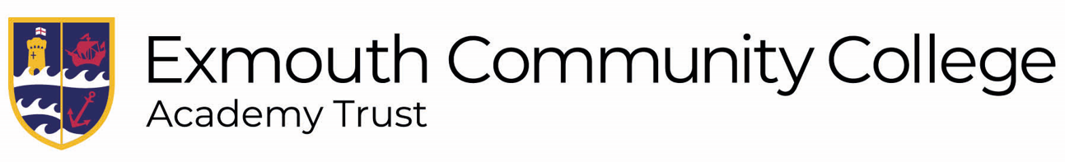
Sixth Form Entry Requirements
The standard entry for a Sixth Form pathway, level 3 including A-levels and Vocational subjects, is 5 grade 4s at GCSE including English Language and Maths.
The standard entry for the bridging pathway, where learners aim to join a Sixth Form pathway after a year of study at level 2, is 5 grade 3s including English Language and Maths
There is no standard entry for a transition pathway, where learners work at level 2 for a year in order to get them to their next step for any reason. This pathway remains at the discretion of the Sixth Form team.
Subject | Additional Entry Requirements
L3
A level
3D Design | 4 in Art GCSE/3D Design/Textiles/ Graphics
Art, Craft and Design | 4 in Art GCSE/3D Design/Textiles/ Graphics
Biology | 6 in Chemistry GCSE + 6 in Biology GCSE/66 in double science + 5 in GCSE maths
Business Studies
Chemistry | 6 in Chemistry GCSE/66 in Double Science + 6 in GCSE Maths
Classical Civilisation
Computer Science | 6 in GCSE Maths or 6 in GCSE physics/66 in double science
Core Maths (4th option for 1 year) | 5 in Maths
Dance | 5 in GCSE Dance
English Language | 5 in GCSE English Language
English Literature | 5 in GCSE English Literature
French | 6 in GCSE French
Further Maths | 7 in GCSE maths + 7 in GCSE physics/77 in double science
Geography | 5 in Geography
Graphics | 4 in Art GCSE/3D Design/Textiles/ Graphics
History | 5 in History
Mathematics | 6 in GCSE Maths + 6 in GCSE Physics/66 in Double Science
Media Studies
PE | 6 in GCSE PE or 6 in GCSE Biology/66 in Double Science
Physics | 6 in Maths + 6 in Physics/66 in Double Science
Photography
Politics
Psychology | 5 in Maths and English
Philosophy | 5 in English
Sociology | 5 in English
Spanish | 6 in GCSE Spanish
Vocational (Single Entry)
Criminology
Early Childhood Development | Clear DBS
Performing Arts
Health and Social Care
Sport | 5 in GCSE PE or Merit in Health and Fitness + 4 in Biology/44 in Double Science
Vocational (Double Entry)
Health and Social Care
Sport | 5 in GCSE PE or Merit in Health and Fitness + 4 in Biology/44 in Double Science
L2
NCFE CACHE Early Years Practitioner
Media
Sport | 3 in GCSE PE or Pass in Health and Fitness
PErforming arts
Ho

