Careers Update
November 2025: Issue 10

CALENDAR DATES: More information is detailed further down

- 8th November 2025 – Swansea’s last Open Day
- 17th November 2025 5.00pm-6.30pm – University Guys Roadshow.
- 17th until 20th November 2025 6pm-7pm – Swansea University Masterclass Webinar Series
- 17th November 2025 4pm-5pm – EDF Apprenticeship Webinar
- 17th November – PKF Francis Clark Open Evening Exeter
- 17th November 2025 4.30pm-5.30pm - Michelmores Graduate Solicitor Apprenticeship Evening
- 20th November 2025 10am-4,30pm – Year 13 Trowers & Hamlins Work Experience Day
- 27th November 2025 4.30pm-6pm – Solicitor Apprenticeship Masterclass
- 22nd November 2025 9am-12pm & 1pm-5pm Devon Diagnostics Sign Ups

Apprenticeship news and events:
Please see below some amazing Apprenticeship opportunities with both local and national companies. Details of how to apply and closing dates etc are advertised on the individual advert. Exeter College Apprenticeship hub is also open and available for drop in or appointment based advice, please see details of their contact information at the bottom of this newsletter.

Here are the details of the next Tesco Stronger Starts Apprenticeship opportunities open for applications now.
Here is the link to the Tesco site
https://careers.tesco.com/en_GB/careers/JobDetail/Stronger-Starts-Retail-Apprenticeship-South-of-England/155663



Apprenticeship opportunities with EDF Webinar 17th November 4-5pm
Join to hear from the Early Careers team at EDF to learn more about their amazing apprenticeship opportunities and the exciting range of vacancies available, which open for applications on Monday 26th January 2026. Offering apprenticeships across the organisation, ranging from Nuclear Engineer to Project Management, Health Physics to Business Administration, Chemistry to Data/DevOps and more.

Degree Apprenticeships in Engineering and IT with BAE Systems
BAE Systems careers have an opportunity to combine your studies with hands-on work, tackling complex problems and building real solutions to keep our world safer. You’ll receive an honours degree, funded tuition fees and a competitive salary. Covering disciplines including Aerospace Engineering, Management, Nuclear Engineering, Project Management, Software Engineering, Information & Technology, and Enterprise Architecture. Applications open in November and close in February 2026, click here for entry requirements and eligibility - Degree apprenticeships (Level 6) in the United Kingdom | BAE Systems Careers
Here are a few current apprenticeship vacancies available on the Gov.uk website, take a look!
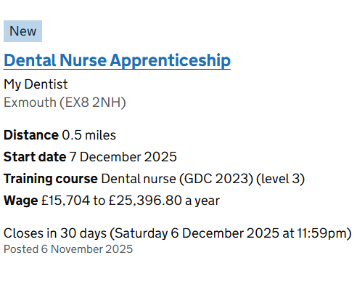
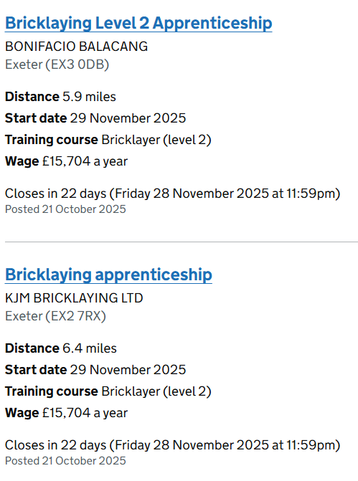
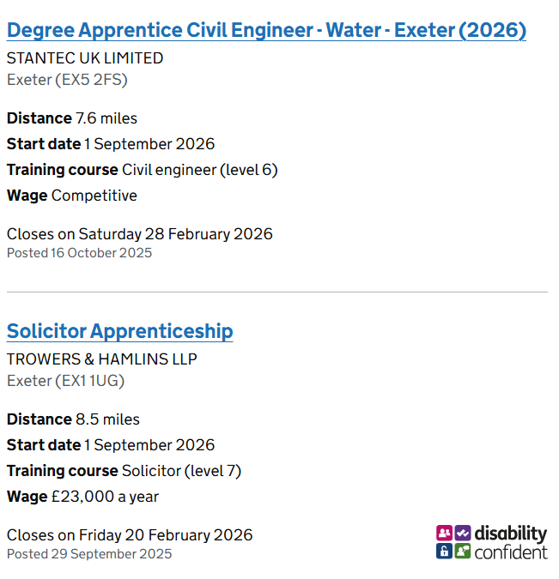
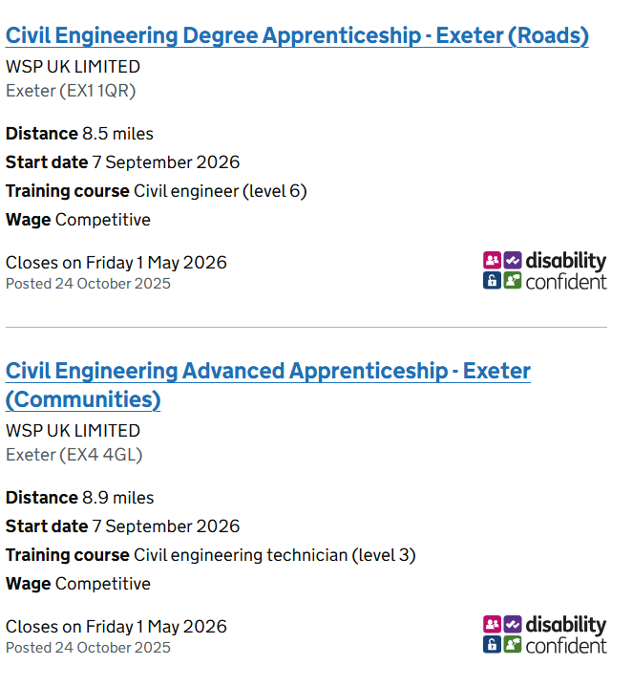
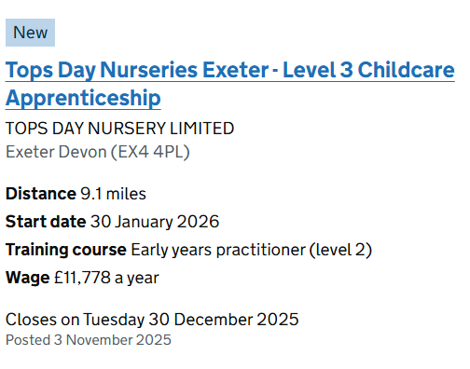
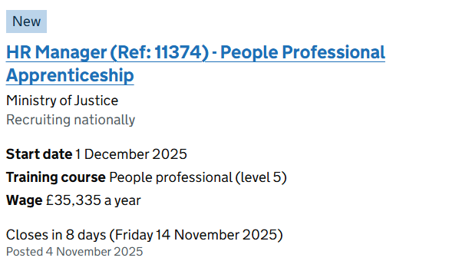

Upcoming Dates and Events:

‘University Guys International Universities Roadshow’ Monday 17th November, 5.00-6.30pm.
Students (from Blundell’s and surrounding schools) and their parents are invited to attend - sign-up link if you would like to attend.

There will be a presentation from 5.15 – 5.40pm and representatives will be available at stands from 5pm until 6.30pm when the event will close.

We will be able to confirm the details of all universities who will be attending approximately 3 weeks before the event. The flyer is to give you an idea of the universities who have visited in the past.
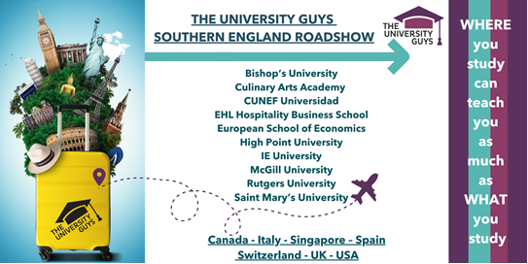

Swansea University
Masterclass Webinar Series is back! – November 17-20th @6-7pm. Tailored for students in Years 11-13, these 1-hour sessions are designed to inspire and inform. Here’s what they’ll gain:
- A deeper understanding of their chosen course and future career path
- Valuable insights to elevate their personal statement
- A first-hand experience of what university lectures are really like
- Direct access to academics to ask questions and explore their field
There's something for everyone from Law, Marine Biology, Medicine, Engineering and beyond! Students can explore and Register Here for their own Masterclass.

Secondly, just to note that the last Open Day of the year is fast approaching this Saturday 8th November. Registration can be found here.

'Solicitor apprenticeship application masterclass, insight session and careers fair' virtual event series for Year 12/13 students, which kicks off later this month on Thursday 27 November 2025 (4:30pm to 6pm).
It features early talent teams from 24 leading law firms.
The session is free and open to all Year 12 & 13 students/Sixth formers. The sign up link is here: https://www.legalcheek.com/fair/solicitor-apprenticeship-application-masterclass-insight-session-and-virtual-fair/

Devon Diagnostics
Time to discover diagnostics! For this academic year, the Peninsula Imaging and Pathology Networks, with Healthcare Sciences, are pleased to announce their diagnostic careers event for students aged 14+ and their parents, (and anyone else who’s interested), at the Horizon Centre, Torbay Hospital on Saturday 22nd November 2025, 9am- 12pm and 1pm - 4pm.
These events showcase the incredible professions that make up radiography, pathology, and healthcare sciences, as well as the career progression opportunities available within the south west. At the start of each session, there will be a welcome seminar to open the event, followed by stall exhibits, and a chance to chat with professionals from across the specialisms. Next steps teams will also be on hand to provide information about entry pathways into these careers.
It's free to attend but places must be booked for each attendee following one of the links:
Morning tickets - https://app.tickettailor.com/events/nhs36/1654536
Afternoon tickets - https://app.tickettailor.com/events/nhs36/1654595





Exeter: Trowers & Hamlins, Work Experience Day - Y13
Thursday 20th November 10am – 4.30pm Trowers & Hamlins, Southernhay Gardens, Exeter, EX1 1UG
✨ What to expect:
- Introduction to Trowers & Hamlins
- Department Talk & Activity
- Networking Lunch
- Department Networking Fair
- Solicitor Apprenticeship Session
- Solicitor Apprenticeship Application Masterclass
✅ Eligibility criteria:
- Minimum of 6 GCSEs
- Achieved grade 6 or above in both English and Maths.
- Predicted to achieve ABB at A-Level.
Follow this link for more information and to book - Exeter: Trowers & Hamlins, Work Experience Day | Event at Uptree

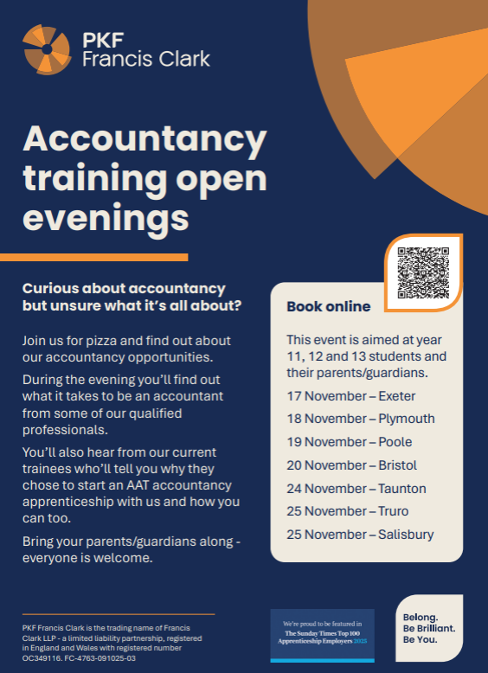

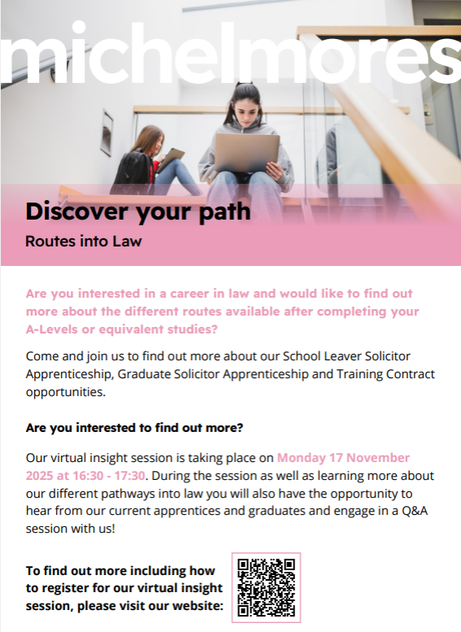

Exeter Maths School – Taster Days


Taster Days for Year 11 students thinking of applying to us for 2026 Entry are now available to book at Ticket Tailor – Exeter Maths School

This year there will be events on Saturday 29th November. Taster Days include a talk and tour of the school for students and parents, and workshops for students in Maths, Physics and Computer Science.

All students who join us study A Levels in Maths, Further Maths and either Physics or Computer Science, with the option to study a fourth subject either with us or with our neighbours at Exeter College.

We don't want students to feel anything is a barrier to them making their application. Your students may be interested to know about:
- Monday to Friday boarding for students who live further away, with a generous bursary scheme to help with fees
- Support for students entitled to Free School Meals, including travel bursaries to support attendance at admissions events, additional practice material for the Entrance Test, and Mock Interviews for those who progress that far
- SEND support through the admissions process, including entitlement to Exam Access Arrangements for the Entrance Test
Students can find out more about the admissions process at the following pages:
- How It Works - the admissions process
- September 2026 Entry - key dates
- Weekly Boarding - information about boarding and bursaries
- Expression of Interest - students and parents sign up here to receive key admissions info by email
You can find Taster Day flyer images here: Single Taster Day Flyer Image for Sharing // Double Taster Day Flyer for Printing



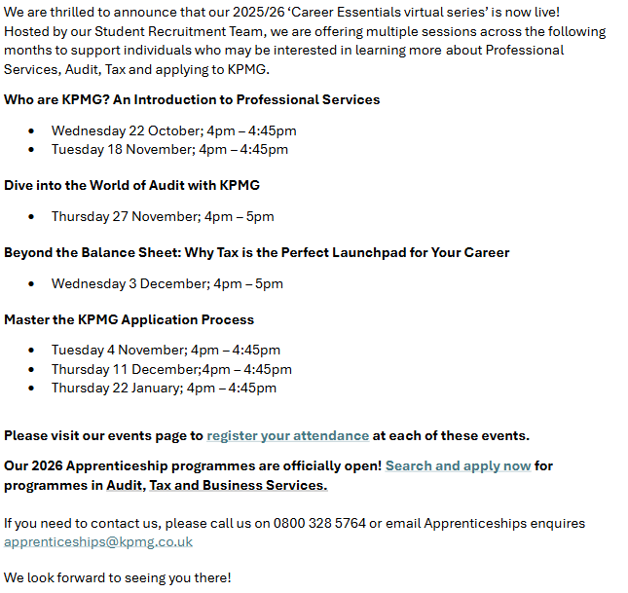

Misc Information:

MoneySavingExpert Advice on Student Loans
Martin Lewis, founder of MoneySavingExpert, has provided essential need-to-knows about the Plan 5 Student Loans for students applying through Student Finance England (SFE) in this article: Martin Lewis' 6 need-to-knows about 'Plan 5' English student finance. Covering repayments, parental contribution and interest its worth a read - Martin Lewis' 6 need-to-knows about 'Plan 5' English student finance

-------------------------------------------------------------------------------------------------------------------------

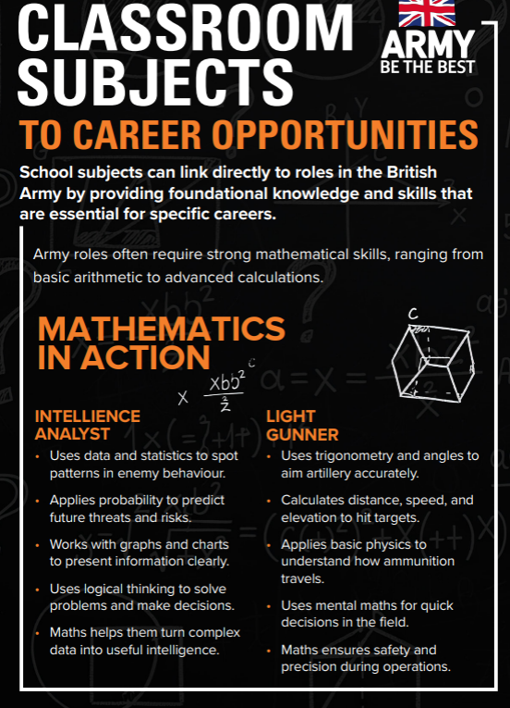

.
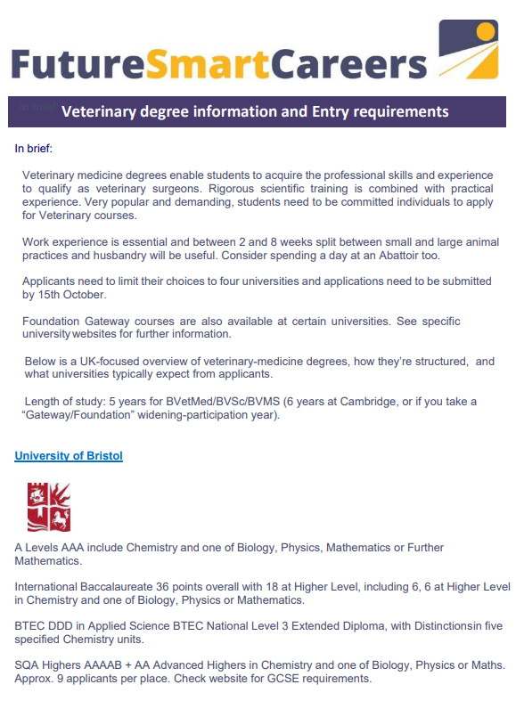

https://www.bbc.co.uk/bitesize/careers
Whether you’re deciding what to study, taking your exams, planning a career, or just curious, BBC Bitesize Careers are here to explain the world of work, with advice from people who've found the right path for them
Investigate different careers at Career pilot - https://careerpilot.org.uk/job-sectors/sectors

Career spotlight this month – Osteopath
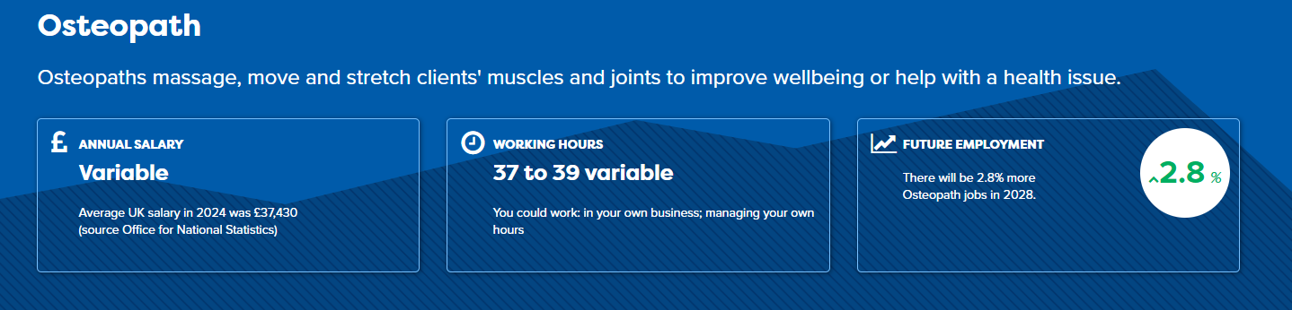

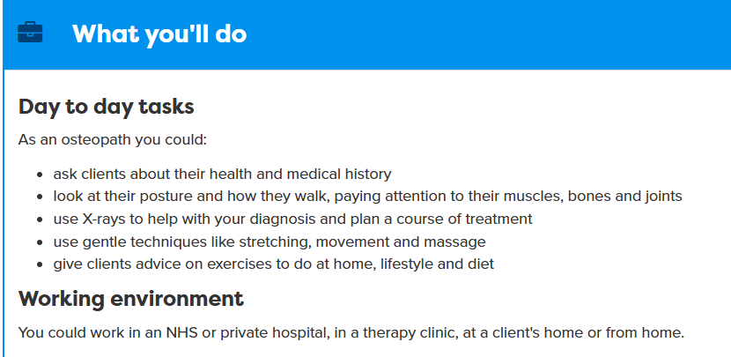

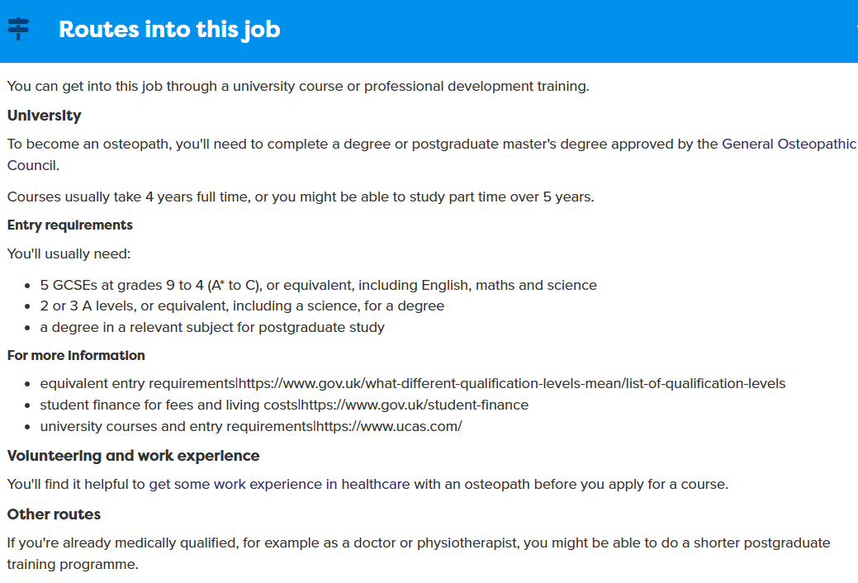

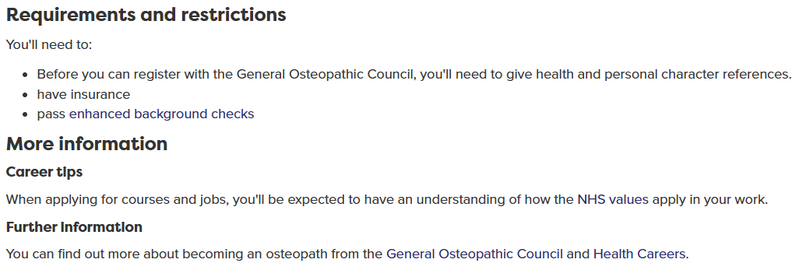


Parent/Carer specific information:

- The UCAS Personal Statement is Changing - A free webinar for students & parents. UCAS have recently amended the personal statement format from one longer essay to three structured questions, affecting all students applying to a UK university from next year onward. Free Events – InvestIN Education



- Information to help parents and carers support young people in making the right decision about study and work
  - https://www.careerpilot.org.uk/parent-zone
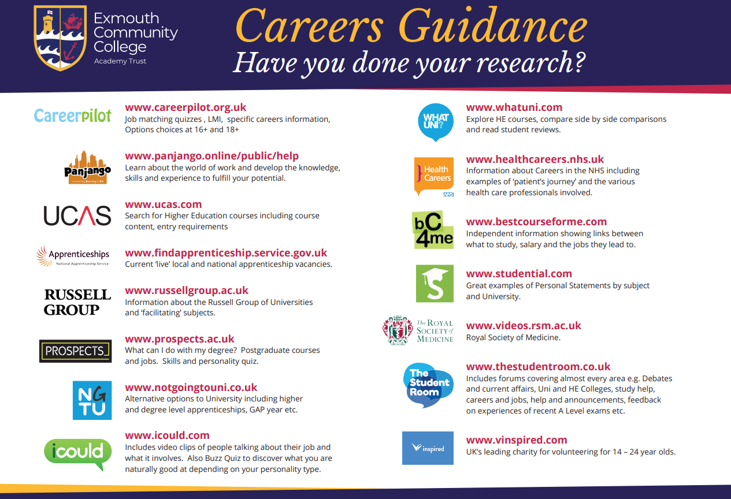

Contact us

Jenna Westcott-Wolstenholme
Head of Careers
Jenna.westcott-wolstenholme@exmouthcollege.devon.sch.uk

Sophie Beardmore
Careers Administrator
sophie.beardmore@exmouthcollege.devon.sch.uk

