

Transitioning from Primary to Secondary School:
Wellbeing Booklet for Pupils and Parents

This booklet is for you and your parents/carers. It has activities and information to help you prepare for moving to secondary school in September.

We hope you find it useful!
Going to Secondary School

How do you feel?

Have a think about going to your new school and the changes that you will face, how does that make you feel? You may be excited by some of the changes, whilst others might make you worry. Remember, feeling worried about any of these things is perfectly normal.
Use two different colour pens and colour the phrases you are worried about one colour and the phrases you are not worried about another colour.

Making new friends | Managing a timetable
Lunch time | Managing a money less system to pay for food.
Having a different uniform | Being on time
Finding way around | Break times
Getting to school | Learning new subjects
Meeting others my own age | Joining clubs
Being with friends | School rules
Homework | Meeting my new tutor
Meeting my new teachers | Being able to do the work
Being with older pupils | Getting changed for sport / PE

Your Worries

Think about the phrases from the previous page and look at the ones you are worried about. Messaging/speaking/emailing with your friends about what your worries are, is a good idea, you will probably find they have the same worries.
Whatever your worry or anxiety about starting secondary school, remember there are positive ways of dealing with it. Together you can try and come up with some practical advice for dealing with that worry. Here are a few of the examples:

Getting lost: Use the school website and look at the maps of the sites. You can get a rough idea of where things are. BUT remember all Year 7’s are in the same boat, no one will know exactly where to go but together you will work it out – and if you can’t there are plenty of people around to ask.


Making new friends: You may not be in the same tutor as your best friends but remember this is a great time to make new friends (as well as keeping your old ones). Tips on making new friends include: starting conversations with others, joining one of the many clubs that secondary schools offer, or simply smiling at someone.

More homework: You will probably find you will get more homework at secondary school. But if you are organised, get the homework done early, you won’t need to worry about it. Most secondary schools offer homework club after school, so you can get it done before you even get home!

What are you looking forward to?
Try and focus on things you are excited about and looking forward to about moving schools! Perhaps write a list below and put it up in your bedroom. Then, when you are feeling worried about moving, have a look at your list and your anxiety will decrease.
Here are some examples!
Science experiments Sport The canteen food

All the clubs Making new friends Art
Seeing friends from other schools

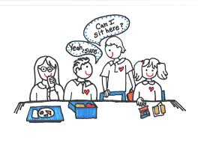





Fact or Fiction

Although there are a large number of positive stories out there about secondary schools, the chances are you have heard some negative ones too. You may have heard them from older pupils, may have seen it on social media, or perhaps a friend of a friend told you?
It is important that you do not believe everything you hear! Below are some examples of stories you may hear, have a think about them and then write down what you think the truth might actually be!

Fiction (stories told by other people) | Fact (the truth!)
It is really difficult to find your way around the school and you will be lost all the time.

The teachers are all strict.

If you get your homework wrong, you get a two-hour detention.

The only way you will not be bullied by older students is if you pay them money.


Problem Solving

Sometimes things are difficult or go wrong at secondary school, it is normal, it is life. We have to learn to deal with them. They could be big things or small things.
There are many people who could help you when things are difficult or things go wrong, but you do need to ask them for that help. They are not mind readers!

Friends: As we mentioned earlier, your friends may well have the same difficulty or problem as you (although they may not have mentioned it). Ask them for help, work it out together, bring your ideas together.

Teachers: They are there to help. If they don’t know the answer, they will know someone that does. Use them!

People at home: They will be able to help you work out the best person to help with your difficulty or problem. It may well be them, or they may suggest a teacher, or your head of year.

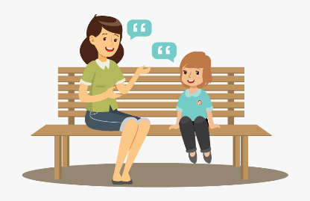

Situation  What is the difficulty or problem | Feeling  How would you feel if this happened to you? | Problem solving – what could you do?  If this situation happened to you, what could you do to best manage the situation and your feelings? | Who could help?  Who would you ask for help and what would you like them to do?
You don’t understand your homework. No one in your family can help, it is due the day after tomorrow.
You have a big argument and fallout with your best friend. You have been friends since Primary school.
One of your teachers shouts at you a lot in class and you think they is ‘picking on you’.
A group of children in your class make fun of one of your friends all the time.
Look at the following situations and think of how you would feel if they happened to you in Secondary School. Then try problem solving each situation to help you best manage your feelings and actions.

Tips and Activities for pupils and parents/carers

Becoming more independent
If you haven’t done so already, think about how you / your child can become more independent at home and have more responsibilities around the house: putting clothes away, making your own lunch, doing the washing and ironing, making a main meal once a week. Secondary school can come as a big shock to some, as you have to be more independent and take responsibility for things. Doing these little things at home can really help prepare for that.

Managing Money
Who will be responsible for budgeting on the pre-paid system? During your time at home you could set up a similar system where you to have to pay for snacks and lunches. Everything has a price! It’s a great way to get used to budgeting and not spending all the money in one day!

Travel Planning
How are you getting to and from school everyday? Can you practise the journey as part of your daily exercise? Or if you are catching the bus, work out where the bus stop is and perhaps research what time the bus comes and drops off.

School Website
On the school website you can look at the maps of the site, look at what clubs are on offer, behaviour expectations, uniform and lots, lots more. It is a great way of getting to know the school that little bit better.

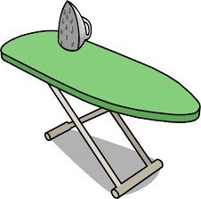
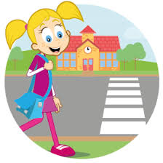


Looking after your Mental Health
Remember feeling worried and anxious is perfectly normal. Right now, many people are feeling this as there has been a lot of change to normal life, again this is completely normal. You probably still have some worries and anxiety about moving schools in September but remember it is natural!
There are some simple ways to manage our worry, anxiety and generally look after our mental health:

- Talk about how you feel: Don’t keep a little worry in your head, talk about it, that will stop it turning into a big worry. Talk to someone you trust, someone at home, message your friends.
- Exercise: Go for a walk, a run, a cycle, a scoot. Anything that gets your heart beating faster counts as exercise. You can also do exercise at home. There are loads of exercise sessions you can follow on online at the moment.
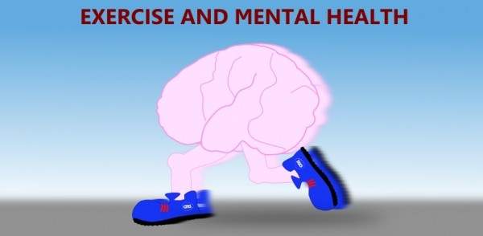

- A good night’s sleep: Sleep is really important for our mental health. If we have a good night’s sleep we are able to deal with our emotions better (including anxiety and worry). Here are some tips to getting a good night’s sleep: Make sure you get some natural light during the day (go outside, make sure you open the curtains), make sure you have a technology curfew (turn off any screens at least 15 mins before going to sleep), if your body is tired from doing some exercise, sleep will come much easier to you.

- Keep hydrated: Drinking water is great for our bodies AND our minds. Being hydrated allows our minds to work properly and therefore gives us the ability to control our emotions better. Official guidelines suggest we drink 6-8 glasses a day.

- Eat healthily: Nobody is saying you can’t have a treat, but just keep an eye on what you are eating. If you can fill your body with enough tasty food that you get all the nutrients you need, you’ll benefit your brain, mental health, mood and your physical health.

- Listen to music: If you are feeling worried about things, put on your favourite music and relax, or maybe have a dance around your bedroom!!! You will let some of the tension out of your body and feel more relaxed.



- Read: It is great to read at any time but at bedtime (once you have turned off your screens!) is a really great time! It will help you sleep better; your brain can start to shut down and you can just focus on the story line of the book rather than your worries.

- Stay connected: This is always really important, but especially right now. We have the technology to keep in touch with people, so send your friends and family a message, video call them, write them an email, write them a letter. Making time and being connected with family and friends is good for our physical, emotional and mental wellbeing.



