Vision, values
and
curriculum reflection
2022

Business

What role do our vision and values at Exmouth Community College play?
Our core principles should inform our decision-making process. It should reflect where we choose to invest resources and drive our decision-making on where to focus our time and energy. It should drive the commitment from staff towards a shared goal and inform our staffing appointments. The values we have should be clearly replicated in the curriculum we deliver to students and the skill sets and knowledge that we wish our students to learn. In essence, we should see these values and this goal reflected in a range of documents, actions and processes across the organisation.
The place of our vision and values within the process hierarchy
How?
Who?
What?
SLT
Middle Leaders
Lesson plans
Classroom strategy
Individual interactions
Classroom practitioners
Operational intent
Departmental RAP
QA processes
Curriculum statement/audit
T and L
Schemes of learning
SEF
AIP
PM
CPD
T and L
HR
Behaviour Management
Board of Governors
Principal
Vision and values
Curriculum intent/audit
Strategic intent

Throughout 2018/19 the College carried out a large-scale debate with parents/carers, students, staff, both support and teaching, as well as Governors. During these conversations each group was asked to discuss the attributes that make a great College. They were then asked to prioritise their thoughts in order to identify the key factors that were most important to them.
After reviewing the feedback from these groups the following vision was arrived at:
Our vision is to create a College for the whole of our community that emphasises the importance of progress and innovation alongside more traditional values such as integrity, honesty and respect. For everyone we will provide the skills, knowledge and awareness to enable all to play an active and positive role in their families, workplace and global community. We will do this through world-class teaching delivered by reflective and skilled practitioners, a broad and differentiated curriculum model and opportunities beyond the classroom.

Characteristics of our students
Our focus groups identified eight key characteristic traits that any students from Exmouth Community College should be able to demonstrate and have been given opportunities to learn and develop during their time at the College:
1. Know how to be healthy and stay safe.
2. Always endeavour to show resilience to be the best they can be.
3. Be aspirational and understand their career options.
4. Know how to behave well and respect other members of our community.
5. Have confidence and communicate effectively.
6. Be mutually tolerant and empathetic individuals.
7. Be knowledgeable and able to deeply understand and recall information easily.
8. Be skilled in applying this knowledge in a range of circumstances.

Our six core values for every individual associated with the College
The discussions also gave some clear indications about the core values that members of the student, parent/carer, staff groups and Governors felt were important and which provide additional guidance on decision-making, curriculum intent and the work of the College at all levels.
These values are the foundation for all our work at the College. They drive our search for improvement and ensure that everyone associated with the College understands what together we stand for.

Our six core values
We will always show integrity and operate in the best interests of the College and our learners. Our decisions are based on evidence, honesty and courage. We will not put our own gain above those of the students and always comply with the seven principles of public life.



Learning is difficult. It requires hard work, determination and commitment. Resilient individuals are optimists and always identify solutions and opportunities rather than problems. At our College we will all work harder than anyone else to succeed.


Creativity and innovation are the hallmarks of good learners and amongst the key skills required for any successful organisation. We consistently look forward and find opportunities for ourselves and students to explore. Sometimes we just need to do something different.


We all continuously strive to use our imagination and be curious about the world around us. We don’t underestimate the power of education, shared values and consistency.
We look beyond current expectations and are open to new ideas, feedback and best practice. We keep an open mind; embrace the challenge, persist in the face of setbacks and regard effort as the path to mastery. We find inspiration in the work and success of others through our growth mindset.
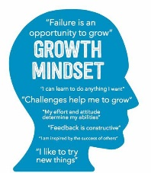
We are proud of our College. We do many things exceptionally well. As reflective practitioners we find opportunities for feedback, listen to it and act where necessary to improve our performance. We always speak highly of our learning community and defend our values to those who might have different views. We are all striving for the same goal. Fearless and dedicated we never give in or give up.


Curriculum reflection

Curriculum intent.
Why do we study Business at Exmouth?
Business Studies has always been an important subject for students. Our economy is underpinned by small businesses employing 1-5 people and providing goods and services. There are thousands of small businesses around the South West and they all help to support the economy and ensure there are future jobs available.
Business Studies has become a well-regarded qualification and is increasing in popularity over the last 5 to 10 years. There are many programmes on TV that have helped encourage young people to become entrepreneurs and small business owners.
Business Studies at Exmouth Community College, is all about helping students understand the complexity of business and management and to give students the opportunity to set up a business for real and learn from that experience. The department is well resourced and staffed with experienced practitioners offering extra-curricular opportunities and visits to local and national businesses.
What is our local context?
Exmouth has a population of 48,613 people. The working population is split into the following sectors:
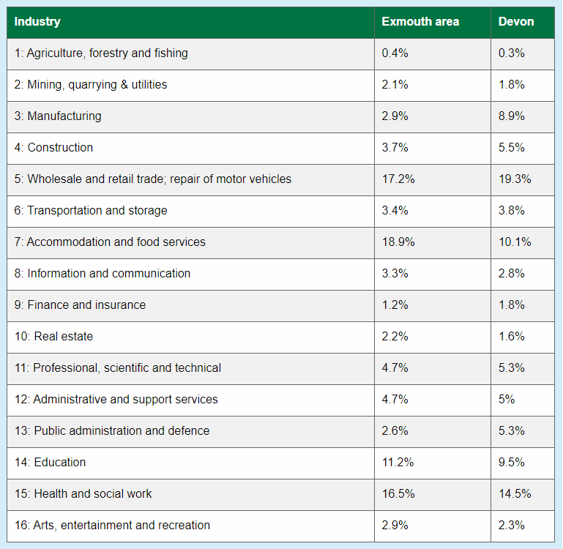
The top three sectors are Wholesale and retail, accommodation and food services and health and social work. These are covered in the courses we study and we use these in lessons as case studies.
For example we look at the retail sectors in Exmouth such as shops and outlets and discuss how and why they have established here but also why some retailers have left the town. We also focus on the hospitality and tourist trade and see how and why local businesses, such as Devon Cliffs, have developed. Finally we look at care homes and see why these have established themselves in Exmouth due to an ageing population (average age in Exmouth is 49) and we look at Market Segmentation based upon age and demographics.
Self-employment in the south west region has increased since 2001:
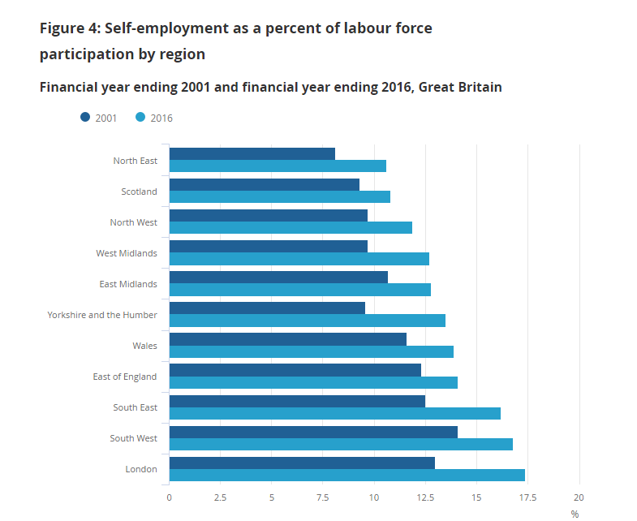
This indicates that a strong entrepreneurial spirit is alive and strong in the south west and something we discuss with our students, particularly through carers advice in lessons and show them videos of young entrepreneurs to highlight the ways they could set up their own Business.
Exeter is our nearest city and has a number of key employers such as Exeter University, The Met Office, Ikea and other large retailers.
We also have connections with the local Chamber of Commerce and are looking at re-establishing links post Covid 19 pandemic.
Chamber Members - Exmouth Chamber of Trade & Commerce

Constructing your curriculum.
GCSE
Qualification aims and objectives
The aims and objectives of the GCSE qualification are to enable students to:
● know and understand business concepts, business terminology, business objectives, the integrated nature of business activity and the impact of business on individuals and wider society
● apply knowledge and understanding to contemporary business issues and to different types and sizes of businesses in local, national and global contexts
● develop as enterprising individuals with the ability to think commercially and creatively to demonstrate business acumen, and draw on evidence to make informed business decisions and solve business problems
● develop as effective and independent students, and as critical and reflective thinkers with enquiring minds
● use an enquiring, critical approach to make informed judgements
● investigate and analyse real business opportunities and issues to construct well-argued, well-evidenced, balanced and structured arguments, demonstrating their depth and breadth of understanding of business
● develop and apply quantitative skills relevant to business, including using and interpreting data.
Year 10 – Basic Knowledge of Business
Aim 1
Key Business terms for starting a new (small) business – types of ownership, enterprise, customer needs, trends, aims and objectives, sources of finance, Marketing Mix, Business Plans, Stakeholders, Influences on Business – OVERALL to support students in being confident in their knowledge base
Aim 2
Using simple and more complex Business calculations
Use calculations in real business examples – such as revenues, costs, profit, interest, Contribution, Margin of Safety and Break Even, Cash Flow and the difference between cash and profit
OVERALL to build in key concepts on maths and apply these in exam situations and class.
Aim 3
Using this new knowledge and understanding of calculations apply these in exam style questions via regular assessments throughout year 10. More focus on the 3,6 and 9 mark questions
OVERALL – to build the students confidence and skills in applying the following:

AO1a – Knowledge
AO1b – Understanding
AO2 – Context (application of the Section B or Section C case study)
A03a – Analysis – linked strands of development
AO3b – Evaluation (balanced arguments and justification of a decision)

Year 11 – Developing Knowledge of Business
Aim 1
Key Business terms for building business – developing types of ownership e.g PLC, How aims and objectives change, Global Business, Developing and changing the Marketing Mix, Making Operational decisions, Making Human resource decisions.
Aim 2
Using complex Business calculations
Use calculations in real business examples – such as profitability ratios, quantitative data, using financial data, ARR
Aim 3
Using this new knowledge and understanding of calculations apply these in exam style questions via regular assessments throughout year 11 – with a key focus on the 9 and 12 mark questions – how to structure more developed essay style techniques to maximise marks. Key focus on:
AO2 – Context (application of the Section B or Section C case study)
A03a – Analysis – linked strands of development
AO3b – Evaluation (balanced arguments and justification of a decision)

OCR Cambridge Nationals in Enterprise and Marketing
In 2020 the department offered a new course that was a more applied route for learners to undertake. This is different to GCSE Business but only in the way it is assessed and how the grades are awarded – P,M or D at level 1 or 2 compared to 9-1 for GCSE.
The course is split into three different assessments – RO64 (the exam assessed unit) and RO65 and RO66 (coursework based assessments.
There is a clear ‘Parity of Esteem’ between both this course and GCSE and students are guided by their preferred method of study rather than any historical data or background information.
Year 10 – Developing knowledge of Business/applying knowledge of Business
Aim 1 – RO64
To understand Key Business terms for starting a new (small) business – Market Segmentation, market research, types of ownership, enterprise, customer needs, trends, aims and objectives, sources of finance, product lifecycle, pricing strategies, sales promotion, business pans, Marketing Mix, Business Plans, Stakeholders, Influences on Business, Operations, HR and functional areas, methods of production

Aim 2 – RO64
To understand key financial aspects of Business. Revenue, costs, Break Even
Aim 3 – RO65
To apply this knowledge in the first part of RO65- coursework
Product differentiation and develop a customer profile, Market Research and start product development
To apply market research techniques and evaluate the product.

Year 11 – Applying knowledge of Business
Aim 1 –RO65
Complete the RO65 and understand how a product is designed and then costed out. To understand how a business may or may not be viable.

Aim 2 – RO66
To be able to develop a brand identity and promotional plan to target a customer profile
Be able to plan a pitch for a proposal
Be able to pitch a proposal to an audience
Be able to review the strengths and weaknesses of a proposal and pitch

A level
The aims and objectives of the Pearson Edexcel Level 3 Advanced GCE in Business are to enable students to:
● develop an enthusiasm for studying business
● gain an holistic understanding of business in a range of contexts
● develop a critical understanding of organisations and their ability to meet society’s needs and wants
● understand that business behaviour can be studied from a range of perspectives
● generate enterprising and creative approaches to business opportunities, problems and issues
● be aware of the ethical dilemmas and responsibilities faced by organisations and individuals
● acquire a range of relevant business and generic skills, including decision making, problem solving, the challenging of assumptions and critical analysis
● apply numerical skills in a range of business contexts.

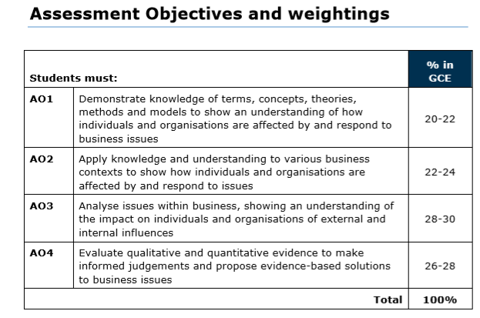

With this in mind the curriculum aims for A level Business at Exmouth are to:

Year 12 – Build Business Knowledge from GCSE (A01 and AO2)
Aim 1- build a passion and knowledge base for all students no matter what their starting point. Some will have studied GCSE Business so will have a base knowledge to build upon. Others mat have not so these students will need to be supported to accelerate their learning. This knowledge base must cover the key topics in themes 1 and 2 such as Marketing, Market Research, Supply and Demand, PED and YED, Design and Marketing Mix, theories of Marketing, Managing People, Leadership Styles, Types of ownership, Finance, Sales forecasting, Break Even, Resource Management, External Influences. The use of a wide range of resources such as the Knowledge organiser will support this.
Aligned to this is encouraging students to read widely and have a holistic view of business via group work, investigations, problem solving, debates and talks/visits from external providers.

Aim 2 – Develop key mathematical and analysis skills. (AO1, AO2) The A level course in year 12 in particular, has a great deal of calculations in it so students must be able to use these in context within lessons and in exam situations. Key aspects in year 12 that must be covered and embedded are:
Market Share, PED and YED, Cash flow, Pricing Strategies, Sales, Revenue and Costs, Break Even, Budgets, Profit, Liquidity, Capacity Utilisation, Stock Control, Sales Forecasting, ARR

Aim 3
Using this new knowledge and understanding of calculations apply these in exam style questions via regular assessments throughout year 12. (AO1, 2, 3 and 4)

Using the assessments throughout year 12 the aim here is to develop students’ knowledge, critical thinking, analysis, evaluation through exemplar A level style questions with case studies. This continued approach throughout year 12 builds core skills in preparation for year 13

Year 13 – Build Business Knowledge from year 12 and prepare for A level final exams (AO1,2,3 and 4)
Aim 1- To develop, embed knowledge of themes 3 and 4 whilst making links to the themes covered in year 12.
The themes in Year 13 to be covered are Theme 3 – Business Decisions and Strategy covering topics such as Ansoff’s Matrix, Porter’s Strategic Matrix, PESTLE, Mergers and Takeovers, Investment appraisal, Decision Trees, Critical Path Analysis.
Theme 4 is Globalisation and students will cover topics that link back to Theme 1. New learning will also cover global economics such as GDP, BRICs, Economic Growth, Exports and imports, Tariffs, Trading Blocs, Global Marketing Mix strategies, Ethics in Business and supply chains.

There will be a crucial process to ensure students make links between the four themes and the interrelated topics link together. This will be achieved through holistic topics/projects and using the mock exams in year 13 that link the topics together.

Aim 2 – Develop critical thinking and analysis skills. (AO3 and 4)
Theme 2 develops more critical thinking skills and allows students to analyse information to make informed decisions. As a more holistic approach students will be given tasks, projects, articles and case studies that provide them with opportunities to become more analytical in their approach.
The emphasis will also be placed on developing their analysis and evaluation skills on the 20 mark questions
Aim 3 – Independent Study skills (AO1, 2, 3 and 4)
For paper 3 students are given a pre-release material that covers all four themes across the course. Students will need to carry out research about the topic and prepare for paper 3. The emphasis will be on students to carry out their own research and also work with others to set possible questions and answers to the topic.
More lessons will focus on students using stimulus material to plan A level style questions and develop a mark scheme for such material. This will in effect make the students think like examiners and come up with a variety of challenging questions and think about the assessment outcomes will be covered.

Curriculum audit tool

Task 2 – Curriculum implementation. Skills and content development
To work up your own sense of the key skills required in your subject and think about where in your curriculum model you are explicitly delivering or developing those skills. Map them out so that you are able to persuade yourself that you are giving students every chance to learn and use those skills consistently across your team.
This is about how your team develop a deeper sense of understanding of key knowledge within your subject. How often is work re-capped? Do you use knowledge organisers as learning homework to embed knowledge and content that you have previously covered. Can they remember work from 3 weeks ago?
How do you give students a sense of how the learning in your subject fits together? What is their sense of the bigger picture? How often do you refer to this bigger picture across the team?
How do you use assessment to help students embed their learning as well as checking and informing teaching?

As a College our stakeholders have decided that the key traits they would like to see our students leave school with are:
Being healthy and staying safe
Being resilient (research shows this can be developed through our extra-curricular activities – “Grit: Why passion and resilience are secrets to success” Angela Duckworth)
Aspirational – understand their career options
Respectful
Effective communicators (literacy, numeracy, speaking, reading and listening)
Mutually tolerant of other cultures and individuals
Knowledgeable
Skilled and able to transfer these skills
You should audit where you believe these skills are being explicitly taught or opportunities given to develop and practice these traits
Departmental area: Business
Impact summary for being healthy and staying safe. Remember to think about Disadvantaged students.

Intent: to ensure that all students have a good understanding of how within your subject area they will lead a healthy lifestyle and stay safe | Implementation (Where is this taught or opportunities provided within your curriculum offer?) | Impact (How do you know that this has been achieved?) | Next steps?  What are you doing to further develop this area if required?
Year 10 | 1.5.3 Legislation in Business e.g. Employment Law, Health and Safety at work, Consumer Law  1.5.2 Technology in Business and staying safe online | Feedback  Assessments | Potential for students to apply this in Work Experience placements and PT jobs
Year 11 | 2.1 Environmental topics are covered | Feedback  Assessments | NA
Post 16 | Theme 1- 1.4 managing people does cover motivation and Maslow’s Hierarchy of needs  Theme 2- 2.5 External Influences – Legislation, Consumer protection, Employee Protection, Health and Safety at Work  Ethical Issues are covered in both Themes 3 and 4 | Feedback  Specific Assessments | Perhaps talks from the H and S executive

Impact summary for developing resilient learners (including through activities beyond the classroom). Remember to think about disadvantaged students
Intent: to ensure that all students have a good understanding of resilience and staff have clear methods and opportunities to develop this in their students | Implementation (Where is this taught or opportunities provided within your curriculum offer?) | Impact (How do you know that this has been achieved?) | Next steps?  What are you doing to further develop this area if required?
Year 10 | 1.4.3 Marketing Mix project. Students have to develop a new form of footwear and work in groups. Presentations are made.  Tenner Challenge – outside of classroom  Assessments throughout year 10 work on students’ revision skills and to support them on improving their examination skills. | Quality of presentations in 2019 were very good and students enjoyed the project. They showed resilience in  Did not run in 2019  Assessment scores do show some progress but also anecdotal evidence shows students are making progress in some of their answers. | Develop student feedback forms  Plan for 2020 as part of the National Programme  Examination techniques need improvement and JS’ work as an examiner will help support this.
Year 11 | Self study and revision techniques.  All year 11 students will be given a pack of revision materials and in the Spring term a letter will go home informing parents how they can support their child through a weekly revision programme. | Positive feedback in 2019 | Prepare even better revision packs for students
Post 16 | Throughout the course there are opportunities for students to work individually, in pairs and in groups to carry out research projects and seminars to present to others.  All Post 16 students will receive a Knowledge Book and Calculations book to support their outside of lesson learning. | Feedback from Year 12 students. | Extend revision packs and Knowledge Organisers across all year groups and seek out new ways of supporting the 5th period.

Impact summary for developing aspiration and giving student opportunities to consider careers in your subject area. Remember to think about disadvantaged students

Intent: to ensure that all students have a good understanding and are inspired by the careers open to them in your subject | Implementation (Where is this taught or opportunities provided within your curriculum offer?) | Impact (How do you know that this has been achieved?) | Next steps?  What are you doing to further develop this area if required?
Year 10 | - Enterprise and Entrepreurship  1.4.1 Options for start ups.  These two elements look at a number of ways students could start their own business.  Throughout the course careers are referred to and programmes such as Dragons Den and the Apprentice are used to illustrate jobs and careers in Business.  Cadbury World Trip | Feedback  Students books  Assessments  Discussions | More outside visitors and trips
Year 11 | Theme two has some excellent elements for students to consider careers and expanding a Business:  2.1.3 Globalisation – jobs abroad are considered.  2.5.1 Effective communication is taught and looks at effective communication in the work place  2.5.2 Effective Recruitment is covered including job roles, types of recruitment, documentation for recruitment and interviews. | Feedback  Students books  Assessments  Discussions | Mock interviews in class?
Post 16 | Extensive examples of this throughout the course – similar to KS4 as the course is similar in content.  1.4 In particular covers a lot about managing people and approaches to staffing. Recruitment and selection are covered.  Being an entrepreneur and managing and leading a Business/people are covered extensively in Themes 2 and 3  Guest speakers (e.g. Ian McQueen) have provided useful insights.  Young Enterprise has opened up job opportunities/WE to our students. | Classroom observations  Student voice | More outside speakers

Impact summary for giving student opportunities to show respect and develop good behaviours for learning. Remember to think about disadvantaged students.
Intent: to ensure that all students are respectful and have good behaviour for learning within your lessons/subject area | Implementation (Where is this taught or opportunities provided within your curriculum offer?) | Impact (How do you know that this has been achieved?) | Next steps?  What are you doing to further develop this area if required?
Year 10 | 1.5.1 Stakeholders – discussions regarding peoples interests in Business and the college is used as an example.  During lessons students are encouraged and praised for listening to each other’s views and the presentations support respect for one another. | Behaviour logs  Student voice  Less TO issued | Need to build more maturity in boys and model behaviour that stops them from falling into silly behaviour. Look at rewards for this.
Year 11 | 2.1.4 Ethics in Business – case studies are discussed  2.3.4 Sales process- role play of how to carry out a sale  2.5.4 Motivation – how a business can motivate its staff. Case Studies used to show we should treat one another in the work place. | Behaviour logs  Classroom observations | Developing more role play situations as case studies
Post 16 | B4L is positive in Post 16 lessons.  The use of independent study, group work, presentations, listening skills and group discussions have all lent themselves to positive Behaviour. | Behaviour logs  Classroom observations | Use of more rewards for post 16  Student of the week?  Greater use of Classcharts

Impact summary for allowing students to develop their confidence and communication skills (inc literacy, numeracy, extended writing, reading and listening) Remember to think about disadvantaged students.
Intent: to develop student confidence through improving their skills of communication (literacy/numeracy, extended writing, reading and listening) | Implementation (Where is this taught or opportunities provided within your curriculum offer?) | Impact (How do you know that this has been achieved?) | Next steps?  What are you doing to further develop this area if required?
Year 10 | Presentation skills are covered in the Marketing Mix task.  Throughout the course students have to utilise reading skills through Business articles and text. Extended writing in seen mainly in the assessments where students have to answer the 9 mark questions. Even the 6 mark questions have elements of extended written work.  Numeracy is used mainly in 1.3 – Putting a Business Idea into Practice – Revenues, Costs, Profits, Cash and Cash flow calculations utilise key numeracy skills.  Listening skills are key in the presentations and whilst watching Business videos | Completed presentations  Assessments  Lessons and assessments  Lesson observations | More work to develop presentation skills would be helpful to develop confidence.  Year 10 – pre course numeracy assessment from Tutor2U would help AFL  More needed from students to listen to one another – some maturity issues with boys
Year 11 | More emphasis on the 9 and 12 mark questions in year 11 – skills such as evaluation, analysis and making a judgement are developed and refined through practice questions and end of unit assessments.  The mock exams will have full feedback and analysis for students to show where they have gone wrong.  2.4 Making Financial Decisions has a heavy numeracy element in it. Ratios are developed from year 10 calculations including ARR  Use of data supports analysis and evaluation skills | Assessments  Lesson observations  Lessons and assessments  Lesson observations  Book reviews and in class assessments | Build in time for more group work and presentations to be made.
Post 16 | Presentations feature throughout the course and students are encouraged to lead others e.g. Xmas Winterwonderland Task.  Young Enterprise has been great for students – meet the public, judges, other teams, work with outside mentors.  Literacy is evident throughout the course due to the literacy heavy content at 8, 10, 12 and 20 mark questions. Students are given much support with this with guides.  Numeracy elements are covered mainly in Themes 1,2 and 3 and calculations such as the ones below are covered:  Market Size and Share  PED and YED  Cost Plus pricing  Cash flow forecasts  Sales, Revenue and costs  Break even  Budgets  Profit  Liquidity  Capacity Utilisation  Stock Control  Quantative sales forecasting  Investment Appraisal  Ratios  Human Resources  ALL students will have a calculations book | Lessons and assessments  Lesson observations  Book reviews and in class assessments | More work is needed to develop students numeracy skills – a number are lacking confidence in this area (student voice July 2019)  Use TSA to seek help/ideas

Impact summary for developing mutual tolerance, awareness of different cultures and understanding the importance of equality and diversity. Remember to think about disadvantaged students.

Intent: to ensure that all students have an understanding of the importance of mutual tolerance, different cultures, equality and diversity | Implementation (Where is this taught or opportunities provided within your curriculum offer?) | Impact (How do you know that this has been achieved?) | Next steps?  What are you doing to further develop this area if required?
Year 10 | 1.5 External Influences on Business  Stakeholder views cover understanding other people’s views  1.5.3 Legislation – covers discrimination in the work place | Stakeholder role play and discussions  Lesson observations  Lesson observations and student assessments | This could be developed further with real case studies  Role play?
Year 11 | 2.1.3 Business and Globalisation covers Marketing Mix in different countries and the need for businesses to be sensitive to local cultures and beliefs.  2.1.4 Ethics in Business – doing what is morally right- case studies and class discussions.  How pressure groups can effect Business. | Lesson observations  Lesson observations and student assessments | More case studies and Youtube clips that provoke discussions
Post 16 | 1.4 Managing People- relationships in the work place – Equal Opportunities – pay differentials  1.5 Leadership styles  3.4.4 Business Ethics  4.3 Global Business includes cultural and social factors- changing the Marketing Mix to meet local needs  4.4 Ethical Issues with MNC’s | Lesson observations  Lesson observations and student assessments | More discussions and what if questions? Moral dilemmas

Impact summary for how your department is ensuring that students have developed a deep understanding of the content within your subject area and when asked students can recount previous work through for instance the regular recapping of knowledge organisers, learning checklists. Remember to think about disadvantaged students.

Intent: to ensure that all students have a deep understanding of the knowledge required in your subject area | Implementation (Where is this taught or opportunities provided within your curriculum offer?) | Impact (How do you know that this has been achieved?) | Next steps?  What are you doing to further develop this area if required?
Year 10 | Virtually all of the content covered is new to students.  Detailed and extensive notes in their books will be created.  Regular assessments help to embed knowledge.  Knowledge organisers are not used yet but could be purchased from Tutor2U and used for homeworks. | Assessments and mock exams  Book reviews  Student voice  AFL | Purchase Knowledge books from Tutor2U for year 10 students as a trial  Mini revision guides for Year 11
Year 11 | Theme 2 starts at the end of year 10 and immediately builds upon the knowledge from Theme 1.  New topics are covered but there is some key reinforcement of year 10 work e.g. Objectives, Financial aspects.  Processes are similar to year 10- notes in books, progress tests and homeworks | Assessments and mock exams  Book reviews  Student voice  AFL | Mini revision guides for Year 11  Revision packs
Post 16 | All students are given the textbooks to all four themes and appreciate the resources available.  They are also given Knowledge Organisers and Calculation Books.  Knowledge is an important part of the course and teachers reinforce this with articles from newspapers, BBC and the Economist.  The new GCSE feeds well into the A level course and those students who have studied Business at GCSE will be much better placed to carry on at A level  Regular exam style assessments are carried out and are fed back to students. | Assessments and mock exams  Book reviews  Student voice  AFL | More external resources  Use of VLE?

Impact summary for developing student skills within your area – you will need to identify what these skills are for your area and how/when you introduce them in order to allow students to apply their knowledge. Remember to think about disadvantaged students.

Intent: to ensure that all students are respectful and have good behaviour for learning within your lessons/subject area | Implementation (Where is this taught or opportunities provided within your curriculum offer?) | Impact (How do you know that this has been achieved?) | Next steps?  What are you doing to further develop this area if required?
Year 10 | Numeracy skills are practiced in 1.3 Putting a Business Idea into Practice – Revenues, costs, Interest, Break Even calculations are all covered as well as cash flow  Literacy skills are covered throughout via extended questions and end of unit assessments. Knowledge, application and analysis skills are covered as well as making a judgement in the 9 and 12 mark questions  Group work/Presentation skills/research skills are covered in the Marketing Mix group tasks and in other areas of the SOW – students also need to listen to others and show mutual respect. Questioning skills are also covered and students are encouraged to ask challenging questions of one another. | Assessments  Mock exams  Practice questions in class  Extended written tasks | Regular practice  Very clinical and didactic teaching to support students in answering the 6,9 and 12 mark questions.  Develop more opportunities in the SOW for students to do more independent learning
Year 11 | Numeracy Skills are again covered in 2.4 Making Financial Decisions – Business Calculations such as ARR, Profit Ratios and sales revenue calculations are covered.  Literacy skills are covered throughout via extended questions and end of unit assessments. Knowledge, application and analysis skills are covered as well as making a judgement in the 9 and 12 mark questions | Assessments  Mock exams  Practice questions in class  Extended written tasks | Regular practice  Very clinical and didactic teaching to support students in answering the 6,9 and 12 mark questions.
Post 16 | Literacy skills are used in lessons for exam style practice questions  Extensive use of case studies for homework activities  Regular end of unit assessments support Literacy as well as numeracy skills.  Presentation and research skills are used throughout the course e.g. in pairs find out about one type of pricing, prepare a handout for others and present to the class. | Assessments  Mock exams  Practice questions in class  Extended written tasks | More work needed on Literacy and numeracy skills in exam style timed questions (student voice feedback and AS mock papers)

